Sorting Trominoes
1. Assumptions I Made
Before writing the code, I had to set a few ground rules to make sure everything worked properly:
- Board Size: The classic L tromino puzzle relies on the board being a power of two to divide evenly. So, I structured my solution for a board size of 2^{n} times 2^{n} (like 4x4, 8x8, 16x16).
- The Missing Square: I built the code so the missing square can literally be anywhere. I added a quick toggle in the main function to either randomize its placement or force it near the middle for testing.
- What Adjacent Means: When the rules say no two trominoes of the same color can share an edge, I took that to mean flat edges only. If two pieces of the same color only touch diagonally at the corners, that's perfectly fine.
- Grid Values: In my 2D array, I used -1 (printed as X) for the missing square, 0 for empty spots, and the numbers 1, 2, and 3 to represent my three colors.
2. Problem Description
For this task, I need to take a square grid with exactly one missing square, and fill the entire rest of the board using right trominoes (L shaped blocks made of 3 squares). The tricky part isn't just making the pieces fit, but I also have to paint each piece using only three colors. The golden rule is that if two trominoes share a border, they cannot be the same color. I had to solve this using both a Divide and Conquer approach and a Brute Force approach to compare them.
3. How I Solved It (Methodology)
I wrote two completely different algorithms to solve this problem.
Approach 1: Divide and Conquer (The Smart Way)
Instead of brute forcing the placements, this method relies on the geometry of the grid. Basically, I start by splitting the main board into four equal quarters. Since there is only one missing tile on the entire board, it's guaranteed to fall into just one of those quadrants. That leaves the other three completely empty.
The main trick to making this work is placing a single L shaped piece right in the exact center of the board. If you orient it correctly, it covers exactly one square in each of those three empty quadrants.
Once that center piece is down, every single quadrant acts like a smaller version of the original problem, since they all have exactly one missing or occupied square. From there, I just use recursion to keep dividing the board down until the function hits a base case of a 2x2 grid. A 2x2 grid with one missing tile is literally just the shape of one L tromino, so the code drops the piece in and returns.
Handling the Colors:
Trying to figure out the colors at the same time as placing the pieces was getting way too messy. To keep the logic clean, I split it into two phases. The tiling function just assigns a unique ID integer to every piece it places. After the entire board is full, a separate function (colorBoardRecursive) runs a pass over the IDs. It tests colors 1 through 3, checks the adjacent neighbors to ensure no rules are broken, and just backtracks if it hits a dead end.
Approach 2: Brute Force (The Guessing Game)
The brute force method is essentially just a massive guessing and verifying loop. The algorithm scans through the 2D array row by row until it hits a 0, meaning it found an empty spot. Once it finds one, it tries to drop an L tromino into that space. Since the piece can be rotated, I just hardcoded the four possible shapes and had the program test them one by one to see what fits.
If a piece actually fits without going out of bounds or overlapping another tile, the code immediately tries to paint it with the first color. It checks the adjacent tiles, and if that color doesn't break the adjacency rule, it locks it in and recursively moves on to the next empty square. But if it hits a dead end, like if no rotation fits or all three colors are already taken by the surrounding pieces, the backtracking starts to take process. It basically undoes the last move, pulls the piece off the board, and tries the next color or rotation until it eventually brute forces a valid combination.
4. Time and Space Complexity
Divide and Conquer:
- Time Complexity: It runs in O(N²) time (where N is the side length of the board). I am basically just visiting and filling every square on the board a set number of times. The coloring phase adds a little bit of backtracking, but since the graph of the board is pretty simple, it finishes almost instantly.
- Space Complexity: O(N²) to store the board array, plus O(log N) overhead for the recursion stack since I keep cutting the board in half.

Brute Force:
- Time Complexity: Exponential. It's roughly O(12^{T}) in the worst case scenario (where T is the number of trominoes). For every single empty spot, the computer might try 4 shapes and 3 colors. As the board gets bigger, the number of guesses becomes huge and time taken becomes too long and not worth it.
- Space Complexity: O(N²) for the board, and O(N²) for the recursion stack, because the recursion goes as far as the total number of pieces I have to place.
5. Comparative Evaluation
Comparing these two is honestly night and day.
The Divide and Conquer method actually understands the math of the problem. It knows exactly where the pieces belong without having to guess, which makes it incredibly fast. You can run it on a 16x16 or 32x32 board and it spits out the answer instantly.
The Brute Force method is totally blind. It will happily stack pieces into a corner, completely trapping itself, and won't realize it messed up until hundreds of recursive calls later. It works fine for a basic 4x4 board, on 16x16 it starts to struggle and take time but it gets it eventually, but if you try to run it on an 32x32 or higher, it essentially freezes because there are just too many dead end combinations to check.
6. Alternative Approaches
For the Divide and Conquer method, my tiling logic is solid, but I could definitely optimize the coloring phase. Right now, I use a backtracking algorithm to assign the colors. A better way would be to treat the finished board as a mathematical graph and use a standard algorithm like Welsh Powell to color it. Even better, there are mathematical formulas that can calculate the exact color of a tromino based on its X and Y coordinates on the board. If I used those formulas, I could color the pieces during the initial placement and skip the second phase entirely.

7. Sample Outputs
Divide and Conquer Result (4x4)
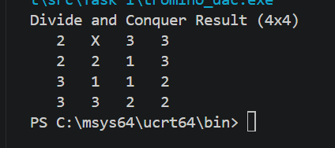
Explanation: Here, the X is the missing square. The numbers 1, 2, and 3 are the trominoes. If you look closely at the shapes, you'll see that no two L shapes made of the same number ever touch on a flat side.
Brute Force Result (4x4)
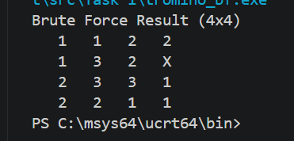
Explanation: It gets the job done for a small 4x4 grid. But if you change the code to an 8x8, you won't get an output because the program will get stuck in a massive loop of guessing and backtracking.
Divide and Conquer Result (16x16)
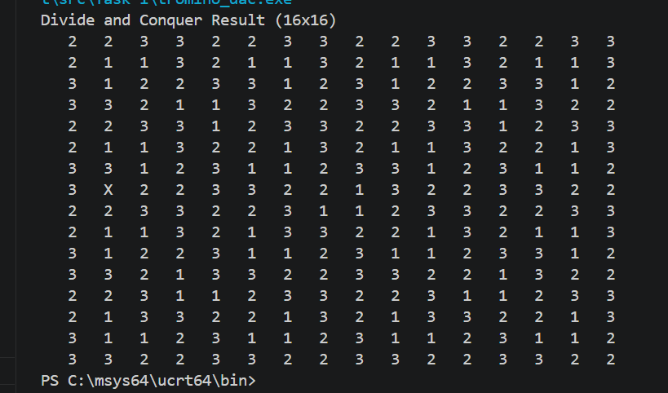
Explanation: Just like the smaller board, the Divide and Conquer algorithm handles the 16x16 grid effortlessly, finishing almost instantly. The X marks the missing square, and the rest of the board is perfectly tiled with the three colors without breaking the adjacency rule. This perfectly demonstrates how well the recursive geometric approach scales up compared to the brute force method, which struggles heavily at this size.
Brute Force Result (16x16)
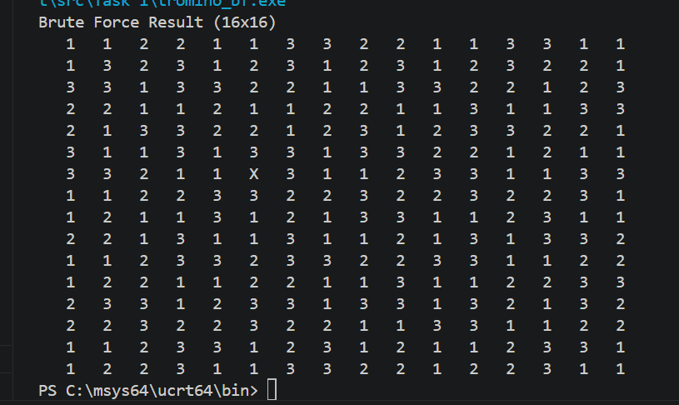
Explanation: The brute force algorithm manages to get the job done for a 16x16 grid, taking up to 30 seconds to find this valid layout. However, this is its absolute limit. If you change the code to a 32x32 board, the program dies and freezes because it gets stuck in a massive loop of guessing and backtracking.

8. Key Findings
The biggest takeaway from this task is that brute forcing a problem is a terrible idea for anything that needs to scale. It’s easy to code, but the exponential time complexity makes it useless for real world sizes. By actually looking at the geometry of the board and breaking it down into smaller sub problems (Divide and Conquer), I turned something that takes forever into something that takes a fraction of a second. It really proves why algorithm design matters.

